Session 1: Assignments

1. Read chapter 2 of the following book:

<http://www.ict.ru.ac.za/Resources/cspw/thinkcspy3/thinkcspy3.pdf>

***Nếu bạn không đọc được tiếng anh, mặc dù không khuyến khích, bạn có thể đọc tài liệu sau để thay thế:***

<http://phocode.com/python/python-cac-kieu-du-lieu-co-ban/>

and answer the following questions:

* How to check a variable’s type?

type(tên biến)

* In what cases, you will get ***SyntaxError*** from the compiler telling you that some of your variables have **invalid names**? Can you give 3 different examples of **invalid names**?

Nam VH

Nam%vh

C4E 11

1. Write a program that calculates the **area** of a **circle**. The circle radius is entered by users

Expected screen output:

|  |  |
| --- | --- |
|  |  |
| # This one is fine | # This one is a little bit better |

1. Write a program that converts **Celsius** (0C) into **Fahrenheit** (0F)

Expected screen output:

|  |  |
| --- | --- |
|  | f |
| # This one is fine | # This one is a little bit better |

|  |  |
| --- | --- |
| http://www.bestappsforkids.com/wp-content/uploads/2012/04/save-turtle.png | ***Turtle exercise*** |

Use Python Turtle to draw the following shapes

|  |  |
| --- | --- |
| 1. **A square** | 1. **A right triangle** |
| 1. **A circle (Hint: Google “*Python Turtle Circle*”)** | 1. **Multi-circles**     Or even better: |

|  |  |
| --- | --- |
| system_config_boot.png | ***Tools preparation*** |

Download and install the following tools, ask TAs for help if needed:

* Git-Scm: <https://git-scm.com/downloads>
* Source Tree: <https://www.sourcetreeapp.com/>

Along with your homework, send us the proof that you’re ready installed these software and have successfully opened them, for example:

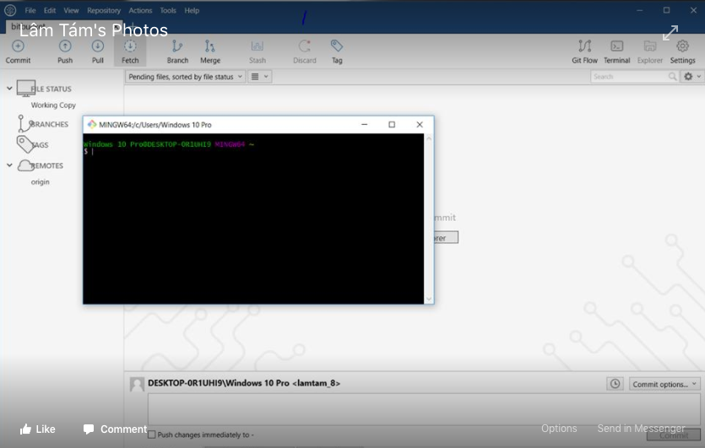

Google: Python Fibonacci